Our Intent

At Hall Meadow Primary School, we aim to inspire pupils and develop their confidence to experiment and invent their own works of art. Our scheme is designed to give pupils every opportunity to develop their ability, nurture their talent and interests, express their ideas and thoughts about the world, as well as learning about art and artists across cultures and through history. Our scheme supports pupils to meet the National curriculum end of key stage attainment targets and has been written to fully cover the National Society for Education in Art and Design’s progression competencies.
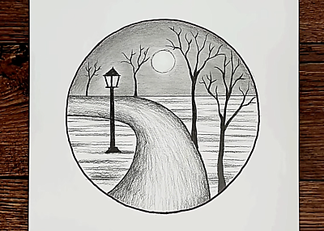
Implementation- How do we do this?
Units of lessons are sequential, allowing children to build their skills and knowledge, applying them to a range of outcomes. The formal elements, a key part of the National Curriculum, are also woven throughout units. Key skills are revisited again and again with increasing complexity in a spiral curriculum model. This allows pupils to revise and build on their previous learning.

Units in each year group are organised into four core areas:

● Drawing
● Painting and mixed-media
● Sculpture and 3D
● Craft and design

Our units fully scaffold and support essential and age appropriate, sequenced learning, and are flexible enough to be adapted to form cross-curricular links with other subjects. Creativity and independent outcomes are robustly embedded into our units, supporting children in learning how to make their own creative choices and decisions, so that their art outcomes, whilst still being knowledge-rich, are unique to the them.
Art at Hall Meadow Primary School

What is the impact?
The expected impact of following our scheme of work is that children will:
★ Produce creative work, exploring and recording their ideas and experiences.
★ Be proficient in drawing, painting, sculpture and other art, craft and design techniques.
★ Evaluate and analyse creative works using subject-specific language.
★ Know about great artists and the historical and cultural development of their art.
★ Meet the end of key stage expectations outlined in the National curriculum for Art.

How will it be measured?
Our curriculum’s impact will be measured through effective pupil voice, staff voice, learning walks, book looks and staff meetings. It will also be reflected through practitioners in the school showing good fidelity to the scheme.

Assessment
Formative assessments at the end of topics will demonstrate children’s acquisition of knowledge.

