Our Intent

At Hall Meadow Primary School, we aim to inspire pupils and develop their confidence to listen and appraise, create and explore and perform music. We aspire to give pupils every opportunity to develop their musical abilities, nurture their talents and interests via exploration of instruments and express their ideas and thoughts about music across the world. Our scheme supports pupils to meet the National curriculum end of key stage attainment targets and has been written to cover a wide variety of musical components.
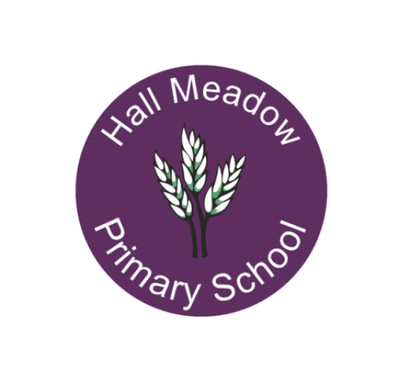
Implementation- How do we do this?
The implementation of our music curriculum is structured, progressive and rooted in the high-quality resources provided by Sing Up. Our approach includes the following key elements:
Integrated Curriculum Design: Music is fully integrated into our broader curriculum, allowing cross-disciplinary learning. We ensure that music education complements other subjects, enhancing overall engagement.

Diverse Learning Activities: Weekly music lessons include singing, listening, rhythm work and the use of instruments. The variety of activities is designed to adapt to meet the needs of all our children.
Singing for All: Weekly singing assemblies are held, utilising Sing Up’s extensive library of songs, covering various themes and cultures, making music accessible to every child.
Performance Opportunities: We organise annual performances of the nativity and our summer show, fostering confidence in our children to perform to a wider audience.
Training and Continuing Professional Development: Staff are trained in the latest music education practices and the use of Sing Up resources, ensuring that our teachers remain confident and adept at delivering high-quality music education.
Music at Hall Meadow Primary School

What is the impact?
The impact of our music curriculum is far-reaching, evident in the musical skills, confidence and personal growth of our pupils. We measure our success through the following indicators:
Enhanced Musical Competence: Pupils demonstrate significant progress in their singing, instrumental skills and musical understanding through assessments, performances and participation in whole school initiatives.
Increased Engagement and Participation: Observations and feedback reveal a high level of enthusiasm for music, with a growing number of participants in extracurricular music clubs (such as musical ambassadors) and activities, indicating a thriving musical community
Cultural Enrichment: Children articulate their appreciation for diverse musical genres, evidenced by their ability to discuss and reflect on various musical traditions and styles learned through the curriculum.

Personal Development: The collaborative nature of our music programme has led to improved social interactions, teamwork, and self-esteem among pupils. Feedback from both pupils and parents highlights the positive impact music has on children’s confidence and emotional well-being.

How will it be measured?
Our curriculum’s impact will be measured through effective pupil voice, staff voice, learning walks and staff meetings. It will also be reflected through practitioners in the school showing good fidelity to the scheme.

Assessment
We employ a range of formative and summative assessment strategies to track pupil progress, including peer and self-assessment, ensuring children are aware of their musical journey.

